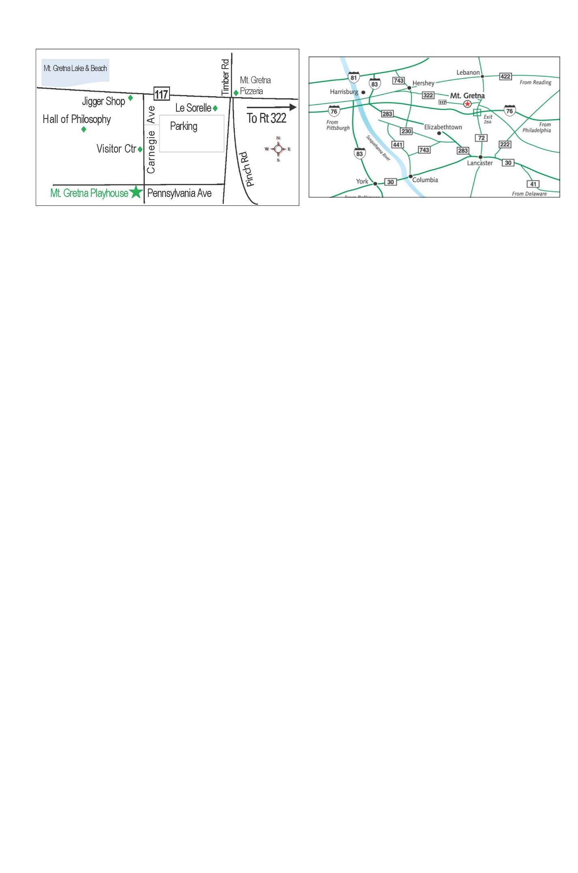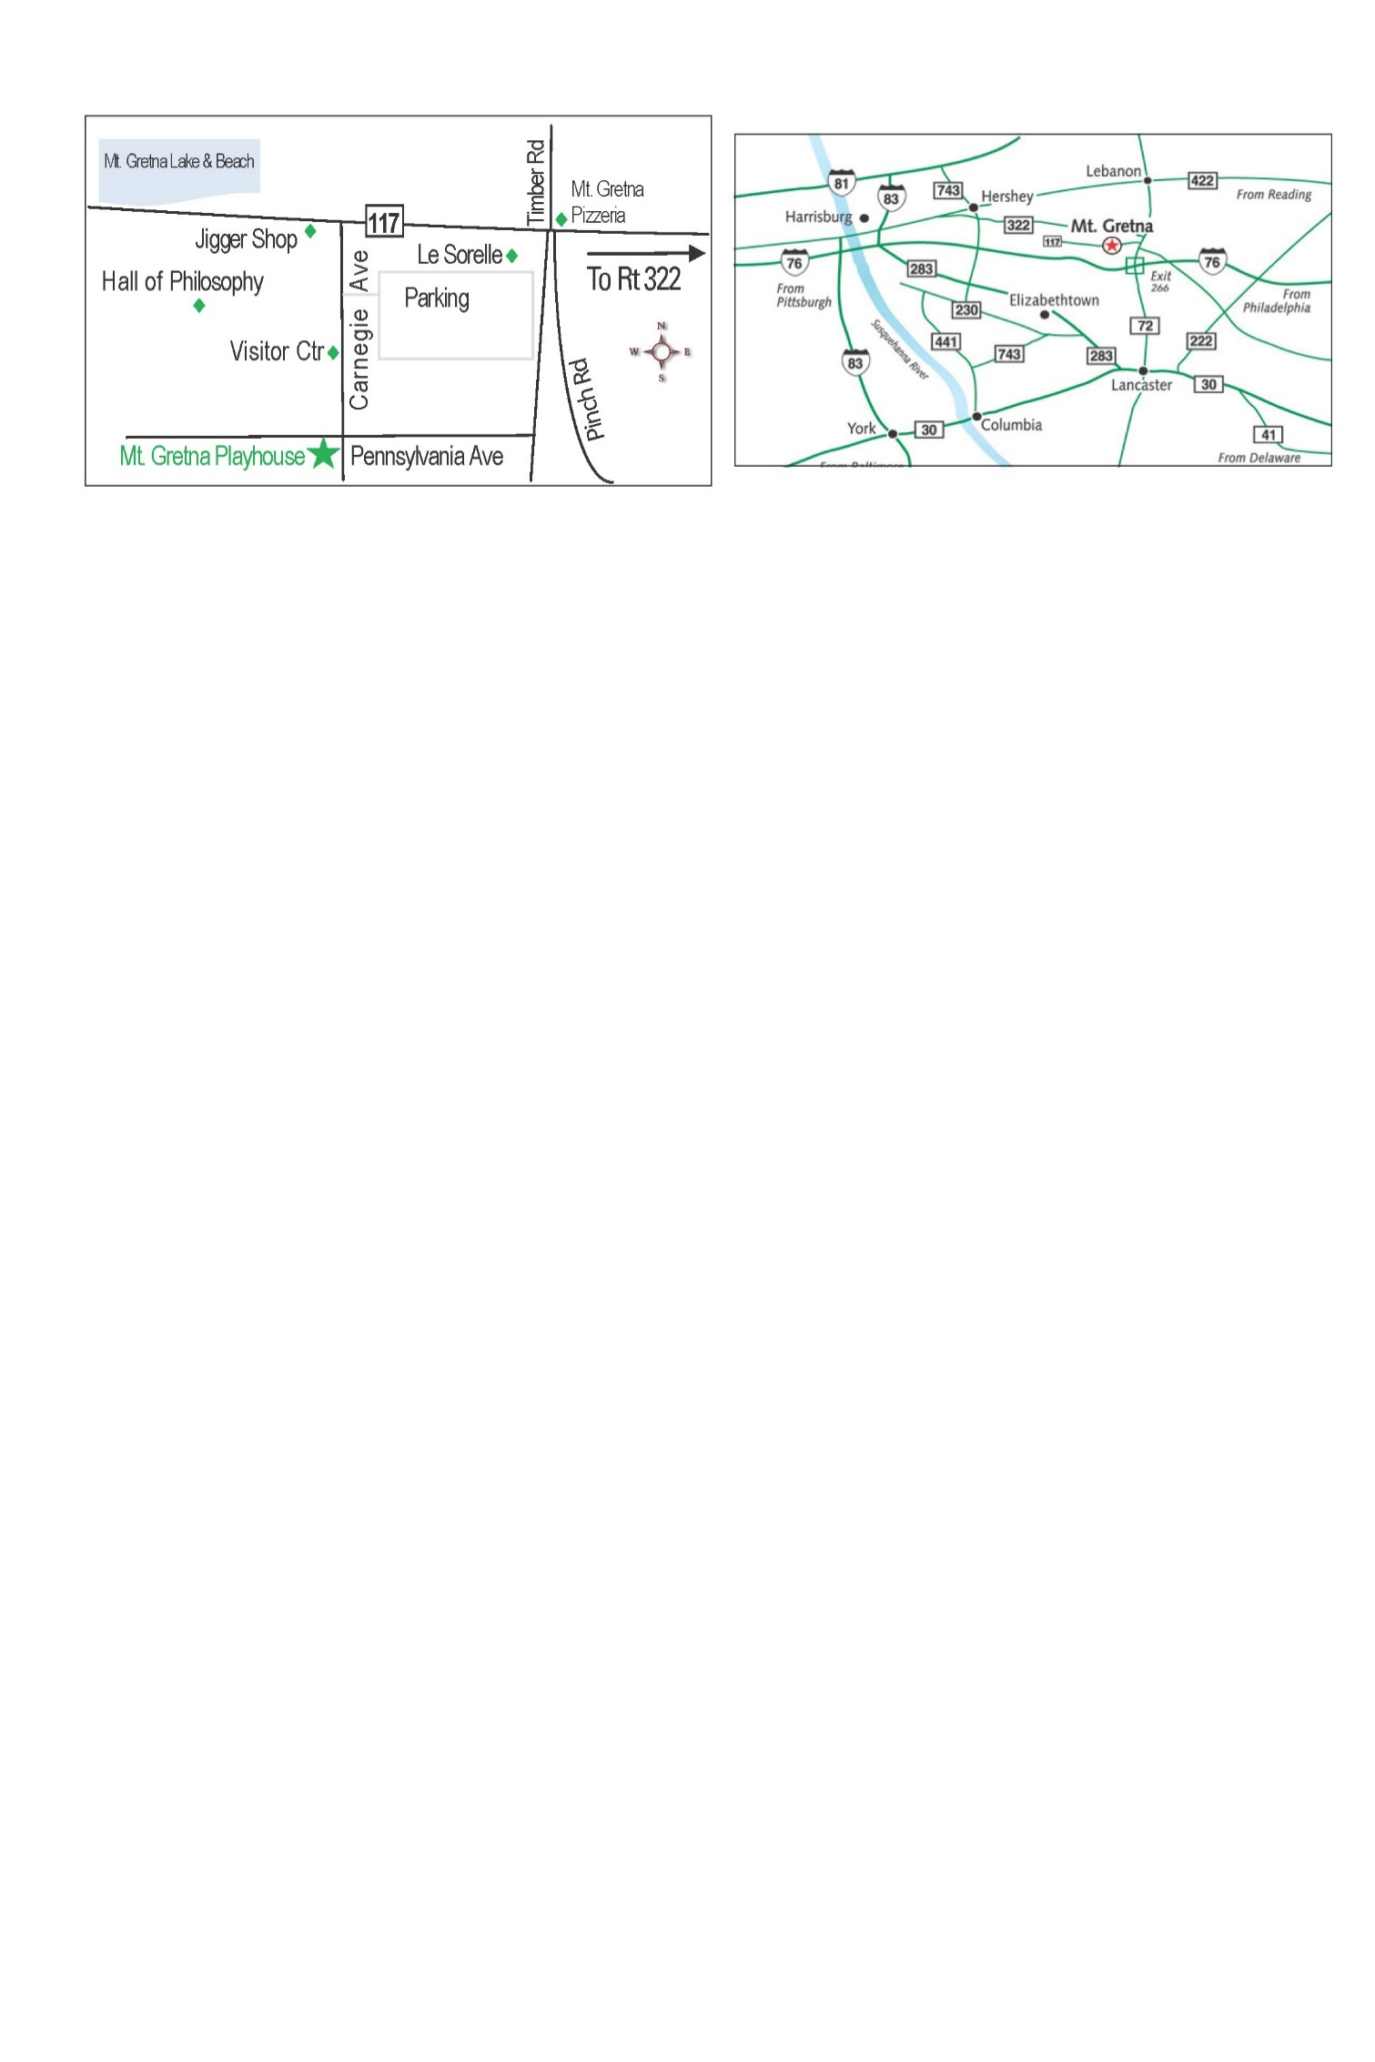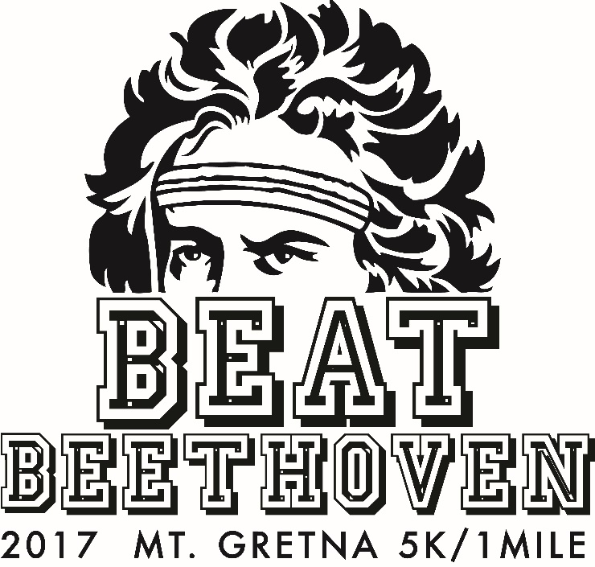

Beat Beethoven

Sunday, September 10

The Beat Beethoven 5K and 1 Mile walk begin at the Mt. Gretna Playhouse. The course will take you through the scenic Mt. Gretna Chautauqua. Bring your trusted and well-behaved side-kick with you because the race is dog-friendly.

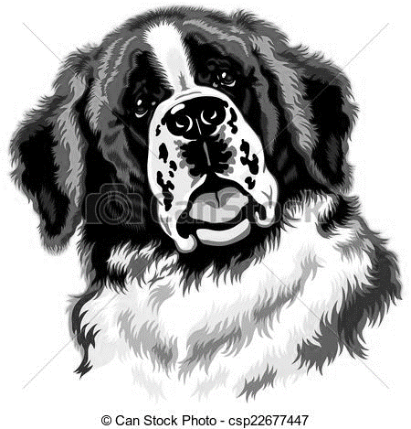

Directions to the Mt. Gretna Playhouse

Located East of Harrisburg, North of Lancaster – Mt Gretna is easily located by either the PA Turnpike or Route 322.  From the turnpike, take exit 266 toward PA-72 S.  From 72, turn right onto Cider Press Road, and right onto Pinch Road.  Pinch Road will lead you into Mt Gretna. If using Route 322, exit to 117 S, Ironmaster Road.  This will become Mt Gretna Road.

Sunday, September 10

8 am

Can you complete the course before Beethoven’s 5th Symphony is finished?

*Proceeds to benefit Gretna Music’s expansion of youth and community outreach programming*.

Sponsored by:

Tiger’s Eye

Arthur Funk & Sons

Bomberger’s

Dr. John Salahub, DPM

Jonestown Bank & Trust

KLB Designs

Still looking for more sponsors.

Contact us for more information.

More info at:

kroyer315@comcast.net

717-361-1508

[gretnamusic.org](http://gretnamusic.org)

Event Details

Sunday, September 10, 2017

Mt. Gretna Playhouse

200 Pennsylvania Avenue

Mt. Gretna, PA 17064

**Packet Pick-up:**

Saturday, Sept. 9th 3:00-7:00 PM

Mt. Gretna Playhouse Box Office

Sunday Sept. 10 7:00-7:45 AM

**5K** 8:00 AM

**1 Mile Walk** 8:30 AM

Registration Info

Online registration at **runsignup.com**

Online registration closes Sept 7 at noon.

All mailed registration forms must be received by Sept 7th. Make checks payable to Gretna Music.

Mail registrations to:

Chuck Wells

336 Hereford Road

Elizabethtown, PA 17022

**Entry Fee:** $25* (received on or before Sept 1)

**Sign up with a Team!** For groups of 5 or more there will be a $5 discount per person.

**Late Entry Fee:** $30* (received after Sept 1)

*No online registration fees apply

No refunds will be given but registration is transferable until the day of the race.

Beat Beethoven

Age Groups:

Male & Female:

14 and under

15-19 years

20-29 years

30-39 years

40-49 years

50-59 years

60-69 years

70 and older

**Awards:**

* + Overall top 3 male and 3 female runners
  + Top male and female runner in each age category

**Amenities**:

* + Chip timing with disposable chips
  + Post-Race food and drink
  + Opportunities to meet Beethoven
  + Race result published online at: [www.appliedracemgnt.com](http://www.appliedracemgnt.com)
  + Race T-shirts
  + A ticket to the evening concert! ($25 value)

@GretnaMusic



By signing this application form, I waive all claims for myself, my heir and assigns against the organizers, sponsors, coordinating groups and any individual associated with the event and will hold them harmless for any and all injuries or illness which may result from my participation. I further state that I am in proper physical condition to participate in this race. I give my permission to the media and race organizers to use my name and/or photo in any newspaper, broadcast, telecast, or any other account of this event, without limited obligation of anyone to compensate me thereof.

___________________________________________ Signature - (Parent/Guardian if under 18 yrs)

Registration

**PARTICIPANT REGISTRATION**  Please use one form per participant

Name:________________________________________

Address:______________________________________

City:_________________ St:________ Zip:__________

Email:________________________________________

Cell Phone: ___________________________________

Emergency Phone:_____________________________

Age as of 09/10/2017: __________________________

Gender: ______________________________________

First 5K? __________________

T-Shirts guaranteed for participants registered by Sept 1st. Supplies limited for late registrations.

T-Shirt Sizes: (circle one)

Adult - S M L XL 2XL Youth - YS YM